Big Data Service with ORM stack

Contents

1. Introduction 3
2. Workflow diagram to deploy the stack 3
3. Create stack for Big Data Service 4
4. Plan the Job 7

Introduction

Big Data Service provisions fully configured, secure, highly available, and dedicated Hadoop and Spark clusters on demand. Scale the cluster to fit big data and analytics workloads by using a range of Oracle Cloud Infrastructure compute shapes that support small test and development clusters to large production clusters.

It provides enterprise-grade Hadoop as a service, with end-to-end security, high performance, and ease of management and upgradeability.

Workflow diagram to deploy the stack

Below diagram shows how the Terraform Artifact are applied in the OCI. While creating a ORM stack, using terraform deliverables Init, Plan and Apply is the flow to provision the resource in the OCI. We can have the deliverables in any of below.

- GitLab/GitHub Repo
- Bitbucket
- Can be in folder/.zip in the local disk
- Object Storage Bucket
- Can be in compartment
- Oracle provided Template

Prerequisite:
- Create Bds instance
- Provide subnet ocid
- Provide SSH key

Create stack for Big Data Service

Go to OCI Console Developer Services Resource Manager Stacks select the compartment Create Stack

My Configuration Folder Browse Select the “Bds” folder that contains the terraform Upload

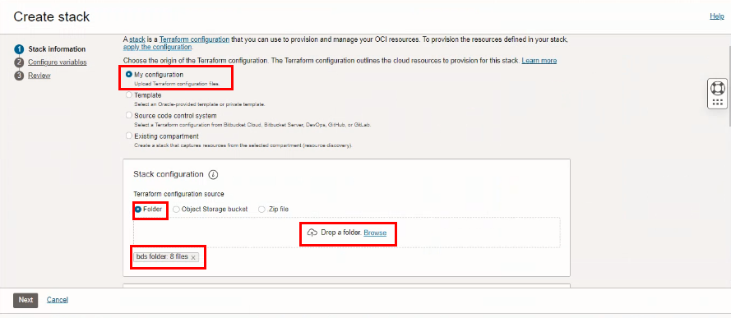

Select the parameters as per the below screen,

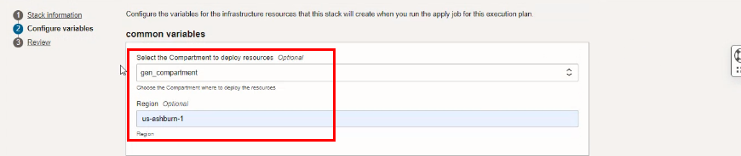
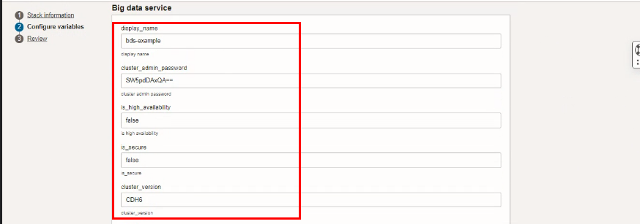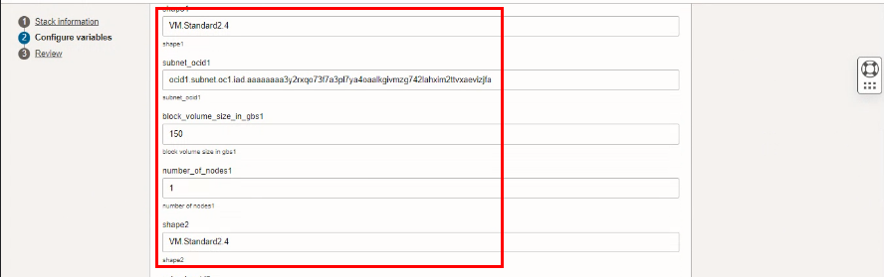
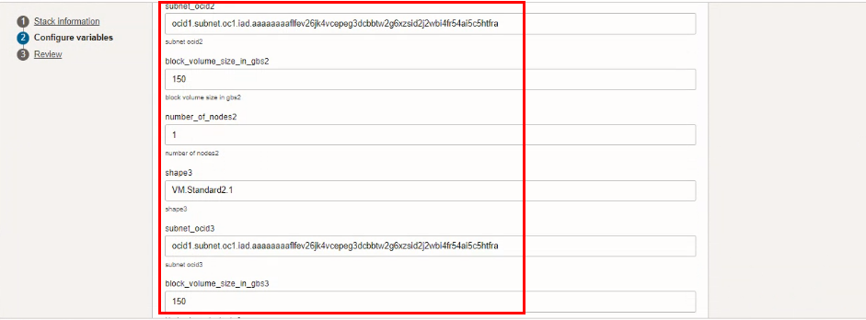

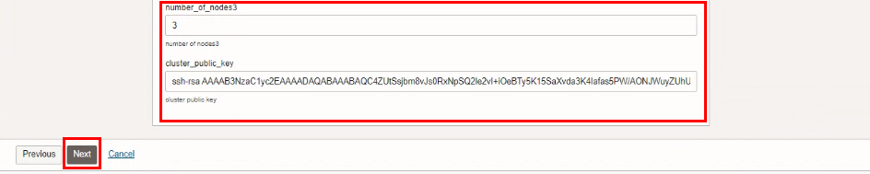

Click “NEXT”

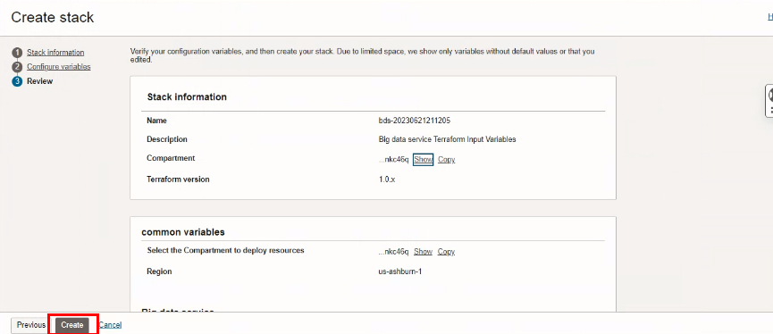
Click “CREATE”

Plan the Job

Click the “Plan”
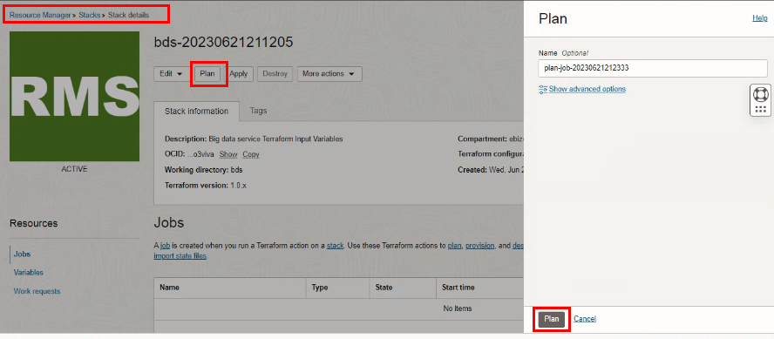

Verify the Plan is successful.

